B.M.S COLLEGE OF ENGINEERING BENGALURU
Autonomous Institute, Affiliated to VTU



AAT Report on

Design and verification of
Digital circuits using Cadence Tool

Submitted in partial fulfilment of AAT
for the course on
Advanced Digital Logic Design

By,
Akshaya Tunga K
1BM24EC009

To
Prof. Ajaykumar Devarapalli
Assistant Professor

Department of electronics and communication
B.M.S College of Engineering
Bull Temple Road, Basavanagudi, Bangalore 560 019
2025-2026

COMPARATOR

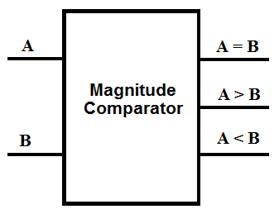

Introduction to Comparator
- A comparator is a combinational logic circuit used to compare two binary numbers.
- It takes two binary inputs, A and B.
- It determines whether A is greater than, less than, or equal to B.
- A 4-bit comparator produces three outputs: A > B, A < B, and A = B.
- Comparators are used in ALUs, processors, digital systems, and control circuits.

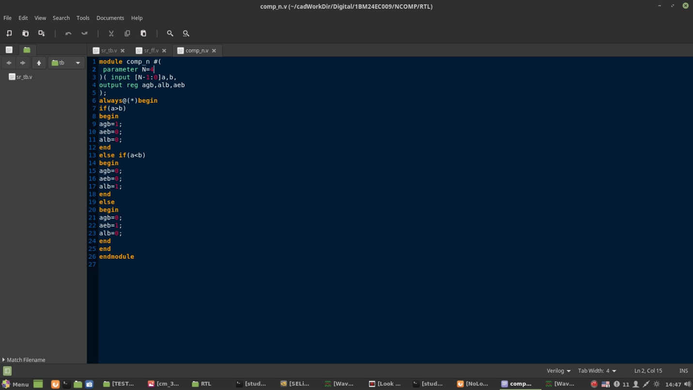
Code:
Testbench:

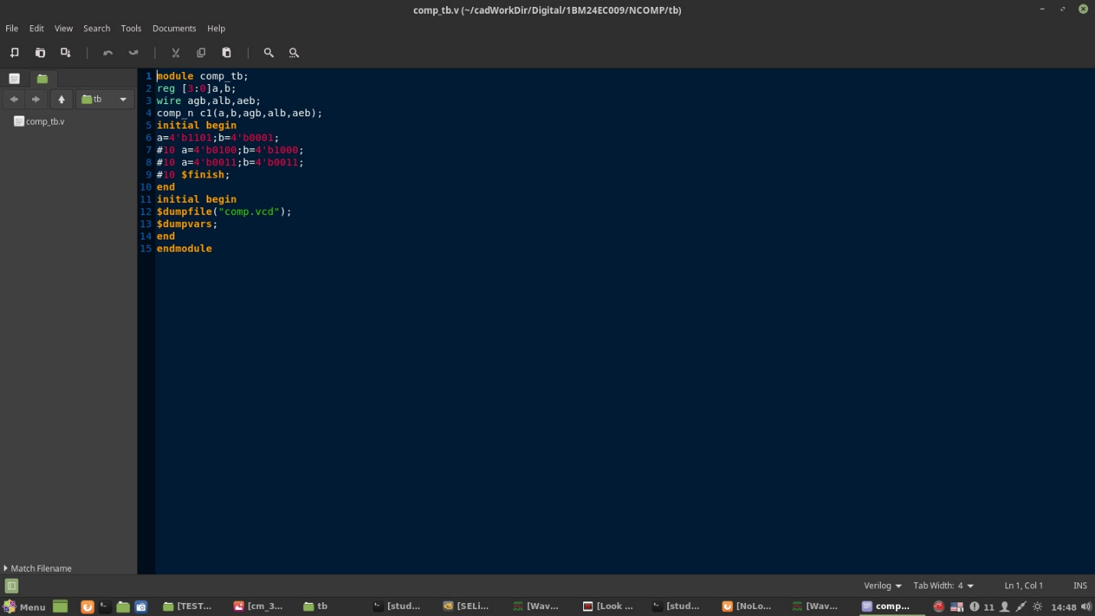

Output:
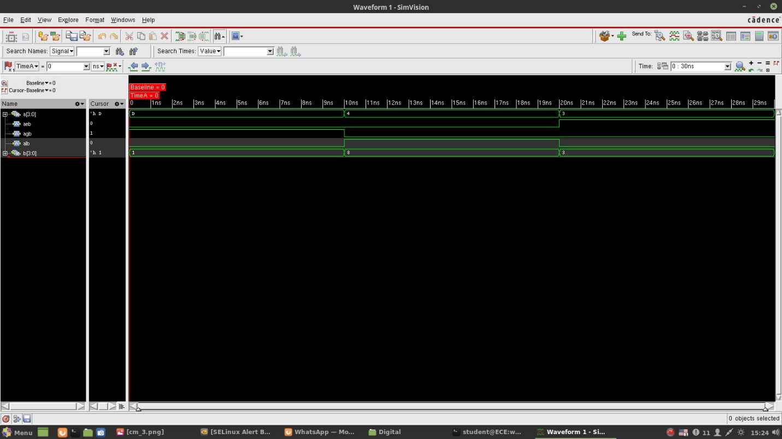

SR FLIP-FLOP
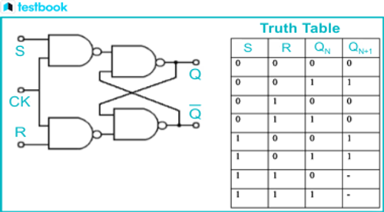

Introduction to SR Flip-Flop
- An SR (Set-Reset) flip-flop is a sequential logic circuit used to store one bit of binary data.
- It has two inputs: S (Set) and R (Reset).
- It has two outputs: Q and its complement \(\overline{Q}\).
- When S = 1, the output is set to 1; when R = 1, the output is reset to 0 (for an active-high NOR-based SR flip-flop).
- When both inputs are 0, it retains its previous state.
- When both inputs are 1, it is an invalid condition for a NOR-based SR flip-flop.

Code:
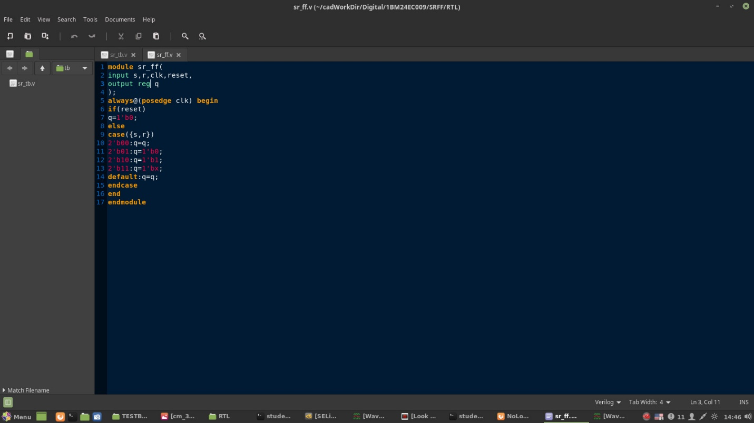

Testbench:
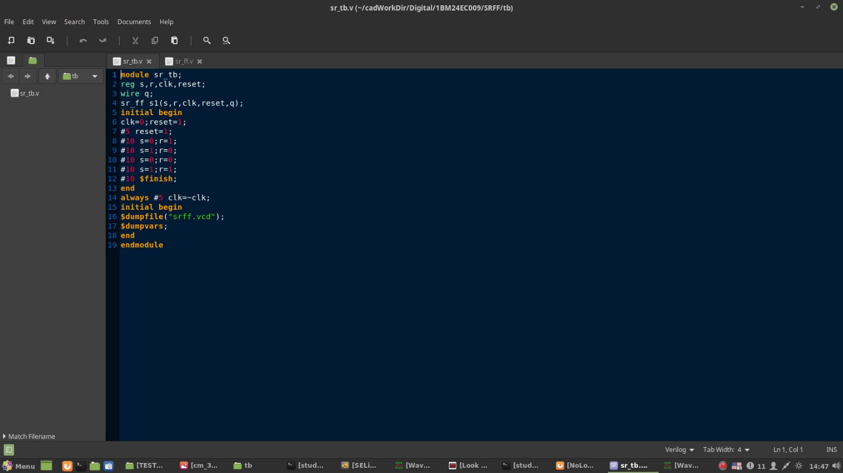

Output:


